

Title: (Template for poster presentation)
Your name and the names of the people who have contributed to this presentation go here.
The names and addresses of the associated institutions go here

Abstract
Advancement in miniaturization of electronics devices and Nano sensors has led to sophistication of Internet of things (IoT) devices. The improved fabrication technology of recent time makes it feasible for Nano sensors to be positioned within the human body, and the terahertz (THz) band is seen as compatible frequency band for in vivo applications within millimeter scale. Link quality and capacity of in vivo has been examined using path loss model where the losses due to absorption and spreading are generalized along with additional permittivity for a considered human model, precisely for skin, water, plasma, RBCs, and whole blood in wireless body area network (WBAN). The variations in link quality matrices such as bit error rate (BER), signal to noise ratio (SNR) and channel capacity have been obtained as these parameters are affected by change in path loss. For the considered scenario, maximum path loss has been observed in plasma with least in the skin.. Therefore, the complete analysis of different body components to obtain SNR, BER, and channel capacity relaying on absorption loss plus spreading loss has been realized. The channel capacity is observed least in plasma, increasing of 2.5% in whole blood, 6.5% in water, 6.7% in RBCs, and maximum of 12.5% in skin

Proposed Technique

Multiple Signal Classification (MUSIC):It is considered to be a high resolution subspace-based DOA technique which gives an approximation of the number as well as angle of arrival of the desired signal.
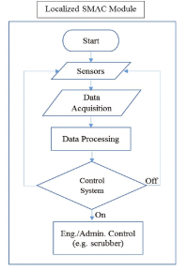
Fig.1. Flow Diagram of Proposed Algorithm

A. Sub Heading X:
Rayleigh fading is a reasonable model when there are many objects in the environment that scatter the radio signal before it arrives at the receiver. The central limit theorem holds that, if there is sufficiently much scatter, the channel impulse response will be well modelled as a Gaussian process irrespective of the distribution of the individual components. The envelope of the channel response will therefore be Rayleigh of the OD centre. Fig. 2(c) represents the output after passing the Kaiser and Hat shaped Kaiser window along all the rows and along all the columns of marked row of image respectively.
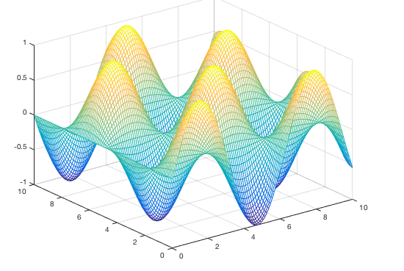

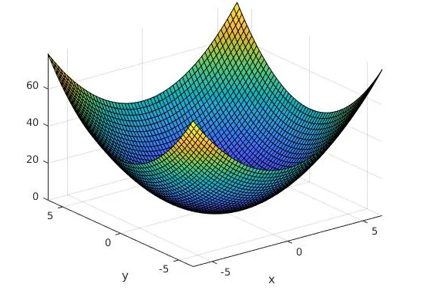

Fig.2: (a) Label X (b) Label Y

The Rayleigh fading is a reasonable model when there are many objects in the environment that scatter the radio signal before it arrives at the receiver. The central limit theorem holds that, if there is sufficiently much scatter, the channel impulse response will be well modelled as a Gaussian process irrespective of the distribution of the individual components.
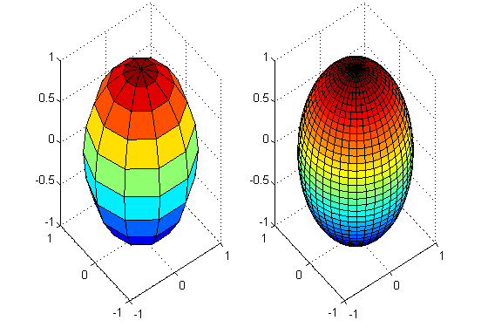

Fig. 3: (a) Label U (b) Label V
B. Sub Heading Y:

The closer the gap between the two angles (8 and10 degrees), the distinction between the two peaks becomes difficult and eventually it gives rise to single peak where $T_{i}$ is the set of neighboring pixels along the row and n is total number of pixels used for threshold selection.

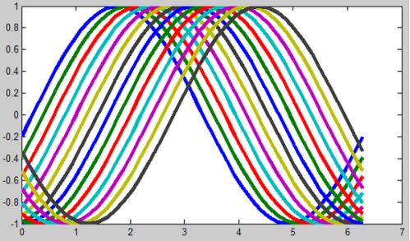

Fig. 4: Label W

Experimental Results
The experiments and validation of the proposed method has been carried out on three different database of fading. Fig. 5 presents the results of the Rayleigh fading detection using the region growing method. Average overlapping scores reported in the Table 1 density of different materials.

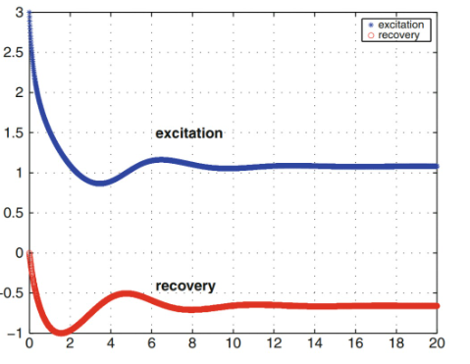

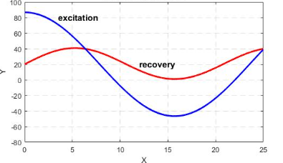

Fig.5: Results of Fading Channels
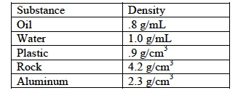
Table 1: Average-overlapping XYZ.

Conclusions
WSN is a powerful controlled system as the nodes run on limited power capabilities, limited computation power and finite battery life it becomes critical to conserve the limited resources in order to increase the lifetime of the network. Prolonging the lifetime of sensor networks thus depends on efficient management of sensing node. The simulated results reveal that the proposed protocol is capable of increasing the network lifetime of a WSN as it considerably reduces the dead nodes and increases the alive nodes in comparison to the original SEP protocol

Acknowledgement
This work was supported in part by the Grants from (if any……).

